**SDP V1.1_FRM5_S6: Speaking Game**

**Speaking Game: Total Duration: 60 minutes**

**Game: Duration: 50 minutes**

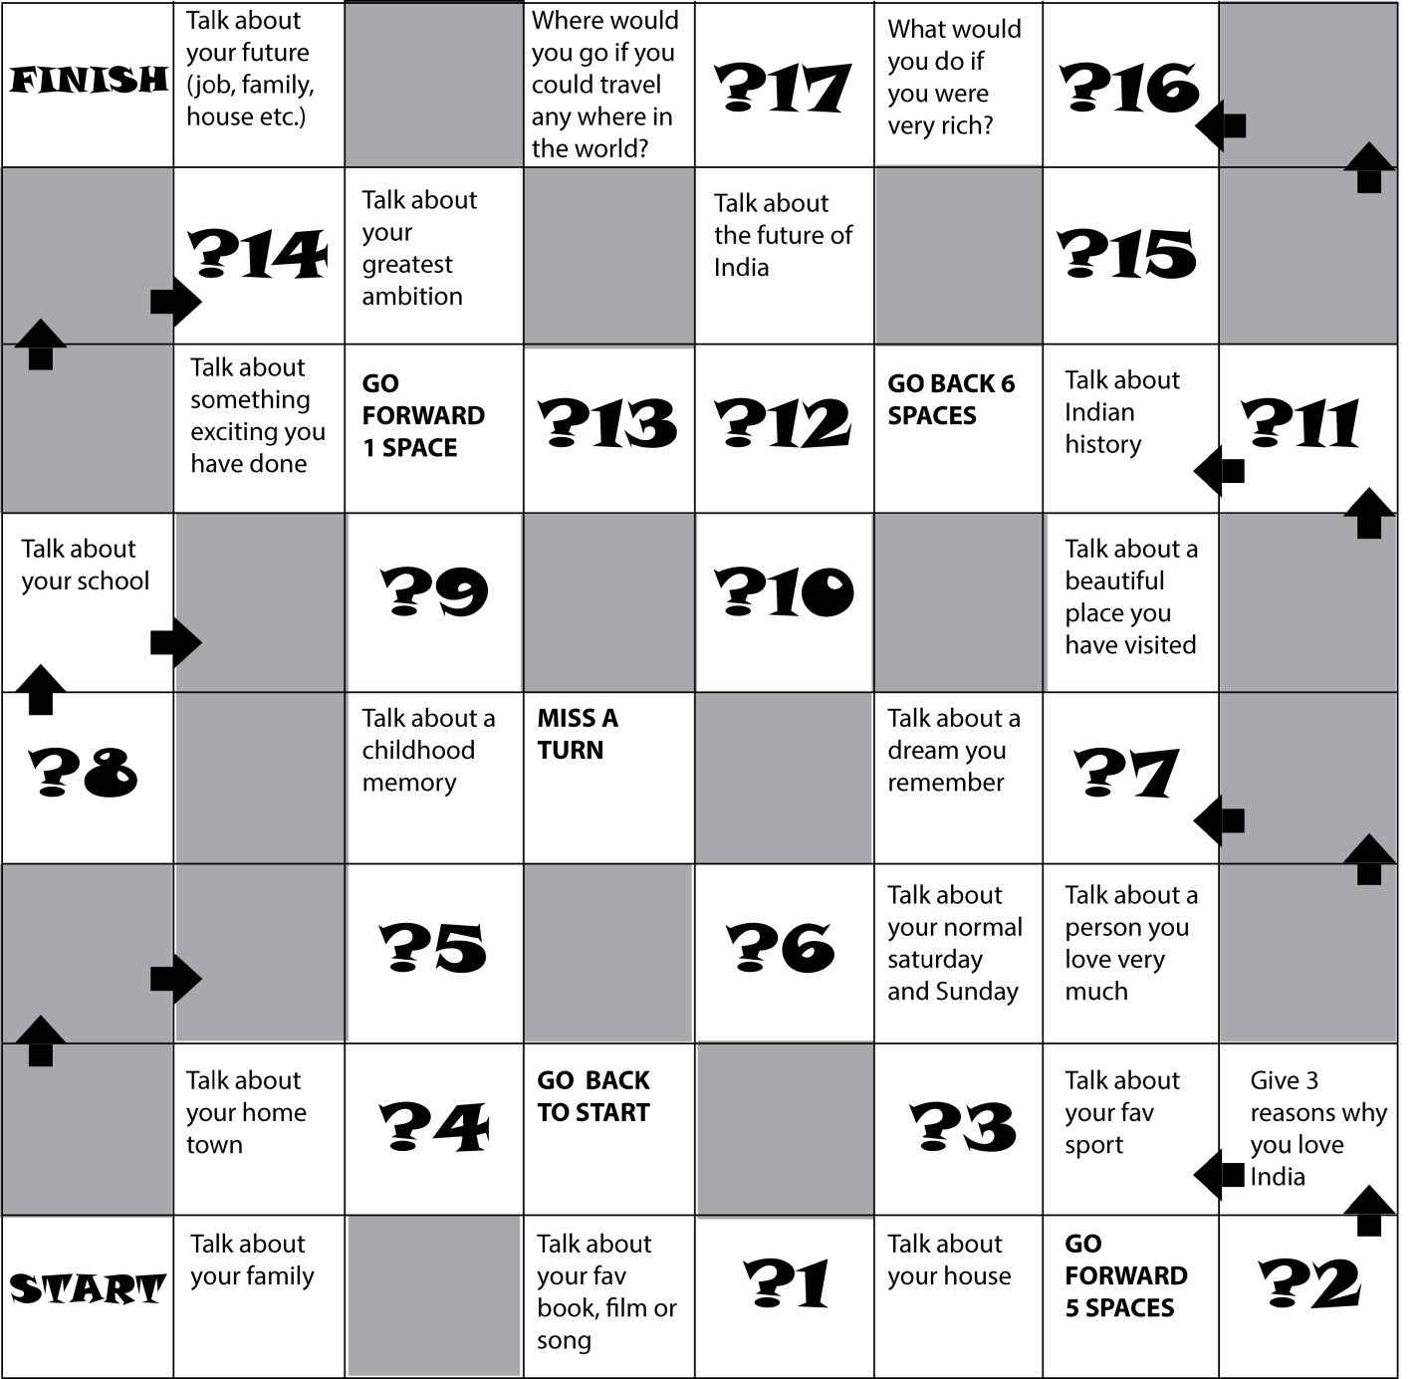

**Materials Needed:**

* Game Boards – 1/group
* Stop watches (mobile with built- in timer is fine) – 1/group
* Dices – 1/group
* **Note:**Questions can be easily changed to suit level of students

**Note:**

* F has to divide Ps into groups of 10 members each. Let 2 groups play and the remaining 2 groups observe.
  + If the total strength is 40, then we have 4 groups – I, II, III & 1V.
  + Group I plays & Group II observes.
  + Similarly, Group III plays & Group IV observes.
* F1 monitors Group I &II; F2 monitors Group III & IV.
* F to provide Speaking Game Boards & dices to Groups I & III.
* Instructions: 5 minutes
* Game: 50 minutes
* Debrief: 10 minutes

**Rules: Duration: 5min**

* Throw the dice and follow the instructions. If you land on a Talk About square, you have to talk for one minute on the subject (another student will time you).
* If you talk for a minute, you receive three points.
* If you land on a “? Square”, the group has to discuss one of the questions below for two minutes.
* Everybody who speaks receives one point.
* When one player finishes, they receive ten extra points and the game ends.
* The player with the most points is the winner.
* **Questions for “? Squares”:**Every time you land on one of these squares, the whole group debates the sentence for two minutes.

**Topics:**

1. Watching TV is a complete waste of time

2. Globalization is good for India

3. Teachers are as important as doctors or politicians, and they should be paid the same

4. Rich countries have a duty to help poor ones

5. How important is employability skills?

6. Love is more important than money

7. Smoking should be made illegal

9. Internet is dangerous

10. Football is boring

11. Films are better than books

12. Chennai is the best city in India

13. Has India become truly “independent”?

14. It is important to think about the environment

15. Hierarchy in organizations should be eliminated

16. Every school in the world should teach in the medium of English

17. Freshers should be paid more